MISSED A YEARBOOK??? GET IT NOW!!!

Purchase any of these yearbooks for only $20 each. Purchase a 2nd for 10% off both, 3 for 20% off, 4 for 30% off and all 5 for 40% off! While Supplies Last!!
(The 2018-2019 yearbook is not included in this promotion.)

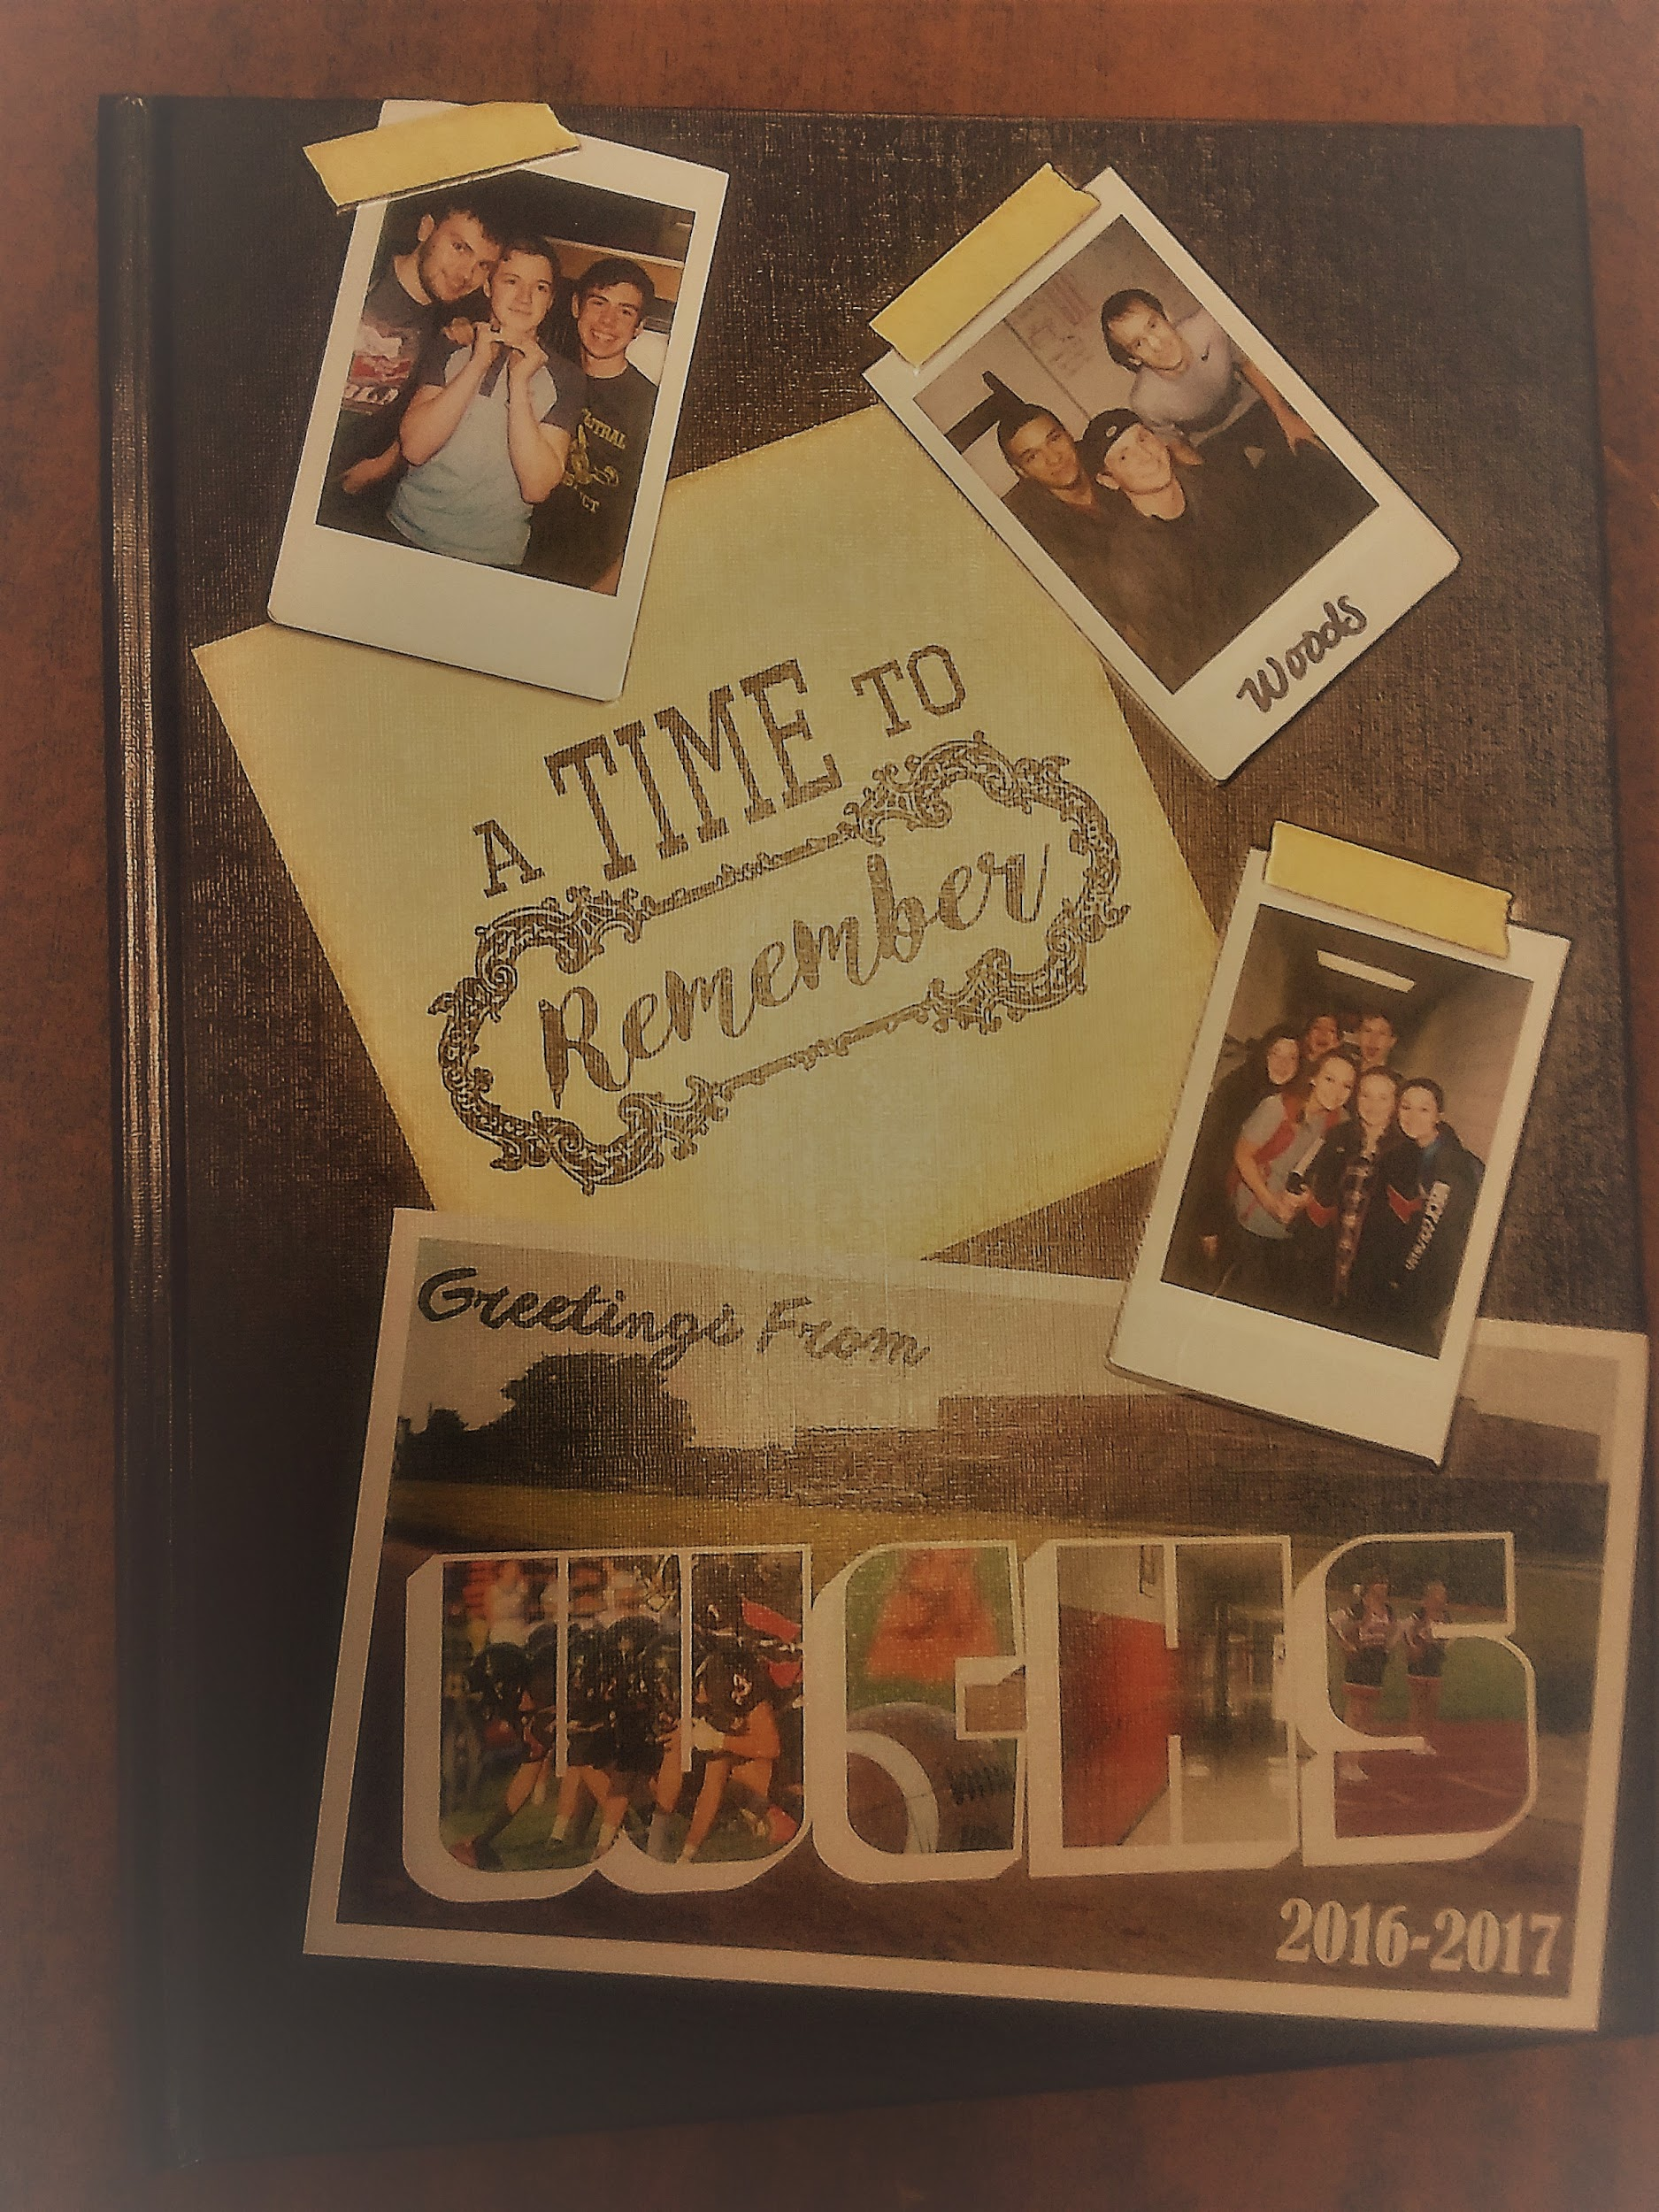 | 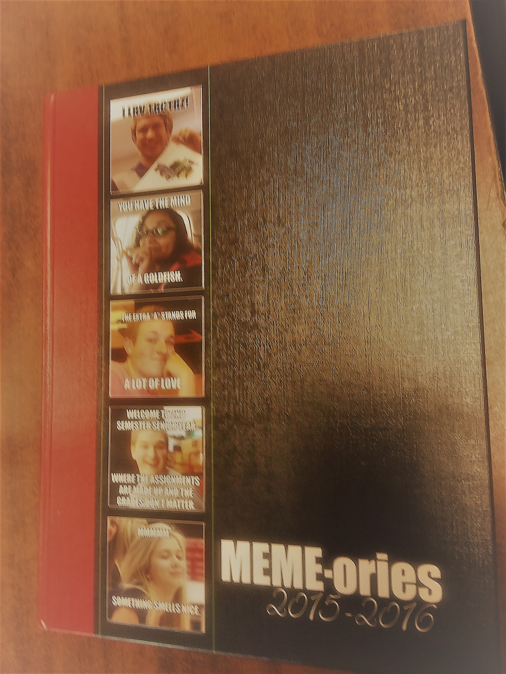 | 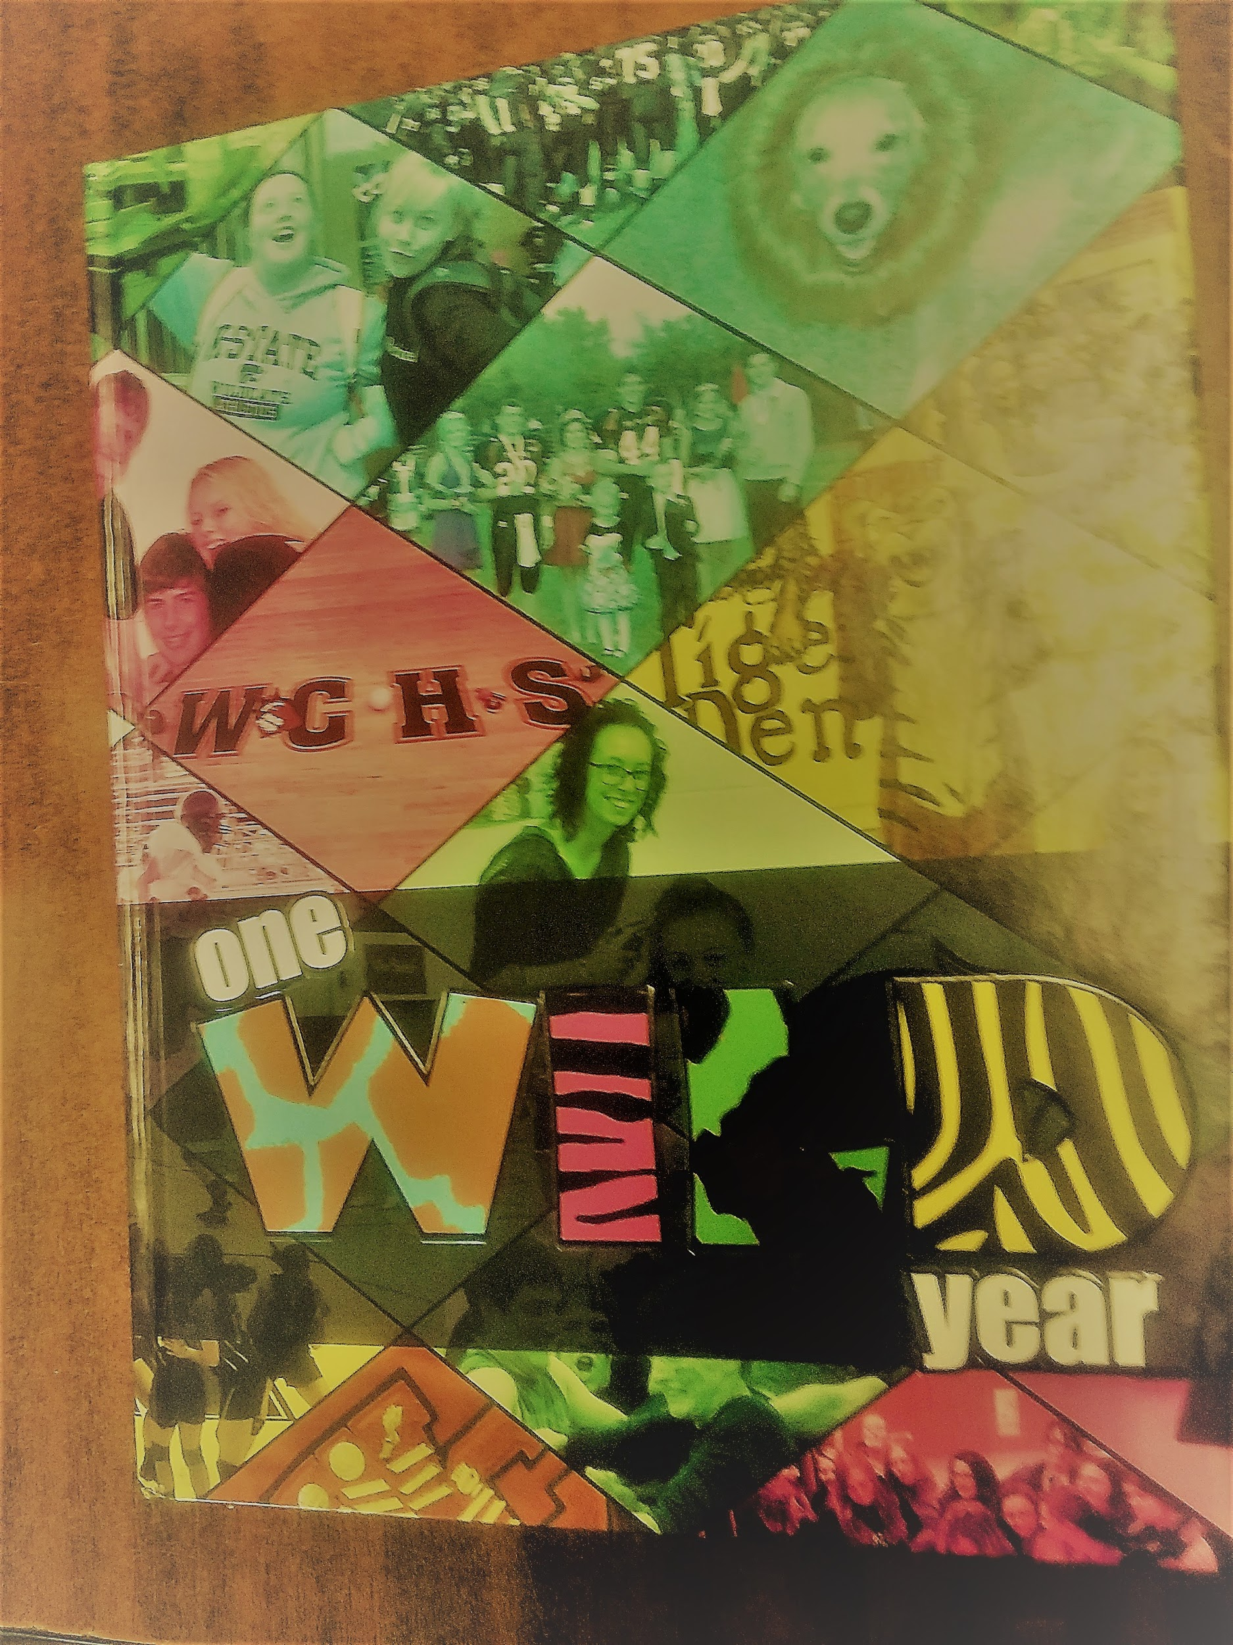
2017 | 2016 | 2015
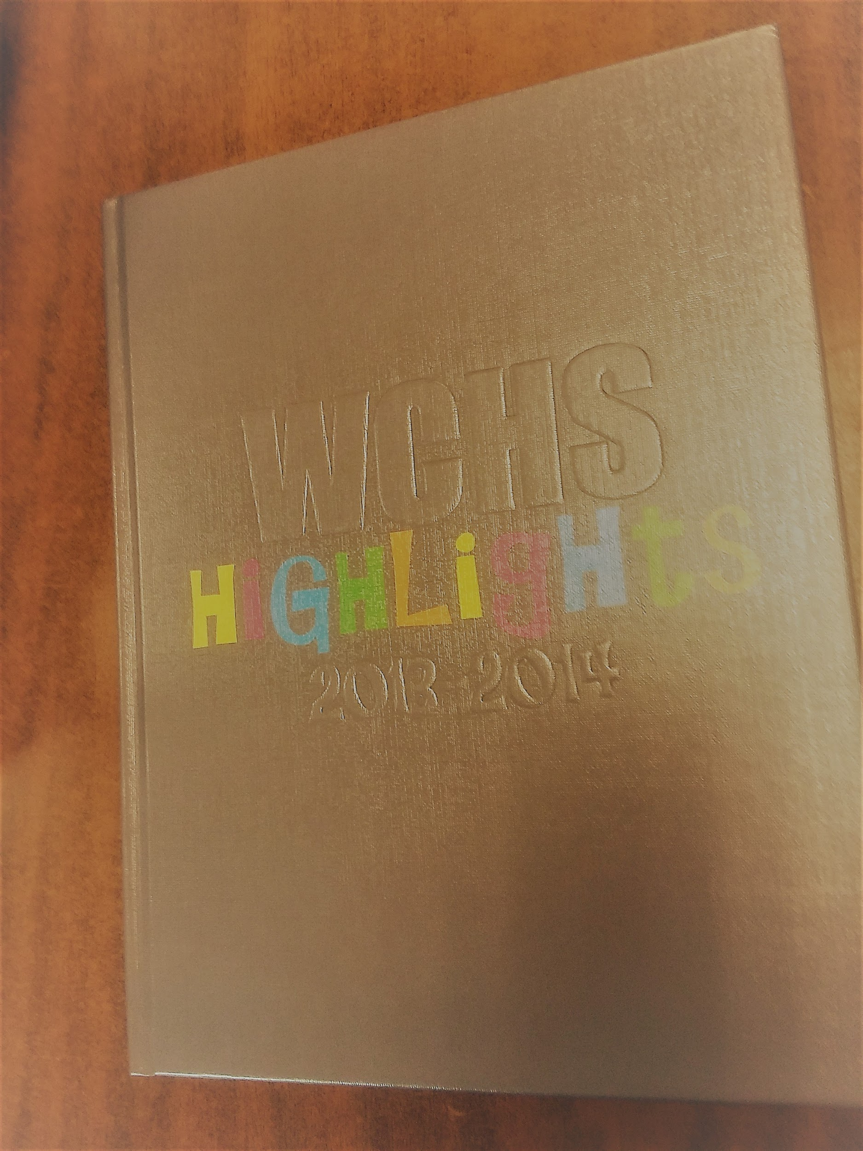 | 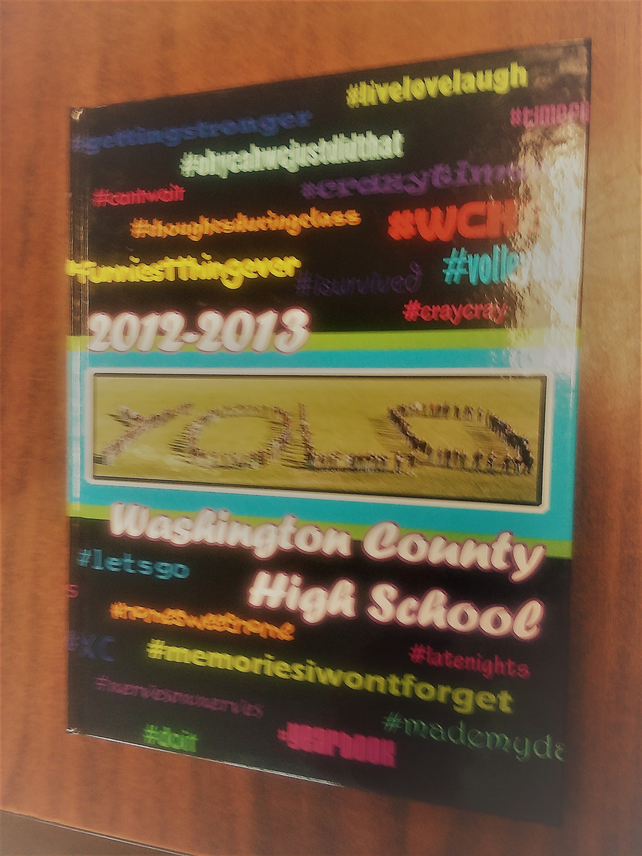 | Choose any book for only $20. Choose two books and get 10% off your total, choose 3 and get 20% off, choose 4 to get 30% of and get all 5 for 40% off your total!  While supplies last!  Please make checks to USD108.
2014 | 2013

Questions? Contact Mrs. Toole at etoole@usd108.org.

