Last updated 07/04/2015

Why some Art students almost never get high grades
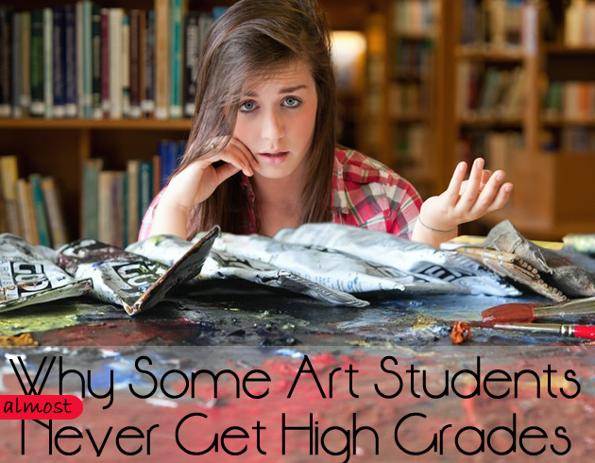
Do you fall short of your potential and gain poor, mediocre or inconsistent results? Are you worried that you will? You may be surprised to learn that certain beliefs, behaviours and approaches hinder your performance in a high school Art classroom; handicap your achievement from the moment you step through the door. This article outlines several of the warning signals that you may underachieve and offers replacement strategies that are used by those who excel.

Warning Sign 1: You find your Art topic boring
Even the most dull and uninspiring subject-matter can be turned into something wondrous. Boredom is a mindset. If your teacher has slammed something unappealing onto the table (engine parts, glass bottles or any other great Art teacher staple), your challenge is to find a way to make these matter. Take a deep breath and look for parallels between what you see and the stuff of your life. Corroded steel joints can echo a faded and broken relationship; light dancing on glass can represent layered memories or dreams. Tell yourself a story. Look for ways to introduce exciting mark-making, techniques and mediums. Take the shapes, lines and colours of your subject and use these as a vehicle to explore something personal and meaningful.
Note: Producing great work is just as difficult given a narrow topic as a wide one. Whether you succeed depends upon how well you respond to the task you have been given.

Warning Sign 2: You forget to bring your things to class
Those who regularly leave work or equipment at home, set themselves up for failure. Every second of your class time is needed. Get organised, and use it well.

Warning Sign 3: You can’t keep up with the pace
Managing the workload in an Art-related subject is hard. Even highly able students find the quantity of work challenging. If you procrastinate, promising to adopt a better work ethic closer to exams (perhaps telling yourself you thrive under pressure), it is worth remembered that rushed work is never as good as that produced using the full allotment of time. If you want to excel in a high school Art class, find a way of coping with the workload requirements now. Learn to paint and draw faster and how to avoid procrastination and get your homework done.

Warning Sign 4: You resent it when others are more ‘talented’ than you
Some of the students in your class might be faster learners, but they reached their current skill level as a result of ongoing practise and effort. No one is born knowing how to paint. If you want to improve your skill, work smarter and/or harder. Believing that others are more talented than you is self-defeating. It curbs effort and encourages dissatisfaction, making you doubt yourself and continually restart and chop and change themes (this is one of the 10 common mistakes made by Art students).
Somewhere in the world, there is always someone better. Take what you’ve got and build it into something great. Make the most of the high achievers you encounter: learn from them, emulate them and compete. Waste not a second on jealousy. No one has your exact background, ideas, techniques or approaches. You can make Art that no one else ever can. Rise to the challenge.
(Even the ‘stars’ in your Art class will eventually get to university and discover that they are surrounded by others who seem more skilful and creative than they are. Many falter when this happens. You have the advantage: conquer this situation now).

Warning Sign 5: You avoid asking questions
Many students see others ask outrageous or obvious questions and trigger an eruption of laughter from classmates. If you have a fear of asking questions and worry that you will appear dim-witted or stupid, remember this: poor results indicate stupidity far more than silly questions. To achieve outstanding success, questions are vital.
The next time you are in a classroom, look around. Who asks the most questions? Who seeks out feedback and help with their work? In almost all cases it is the top students and those who are progressing in leaps and bounds.
It is critical that you ask for assistance whenever it is needed, especially from your teacher (they know your work the best).

Warning Sign 6: You resist modifying or changing your work
Every year, students respond to some teacher suggestions with: “I like it like that” or “It’s fine the way it is”. While you should never blindly follow a teacher suggestion, it is worth remembering that your teacher has your best interests at heart and knows the assessment criteria inside out. They can see your work with fresh eyes and an objectivity that you cannot.
Students who achieve outstanding grades continually refine their work, adding layers, testing materials and techniques and exploring new compositional devices. They don’t avoid critique; they hunt it out – seeking to better their work. Thank your teachers for all of their suggestions; implement some of them and trial alternatives whenever you are unsure.

Warning Sign 7: You blame your teacher for not being experienced enough, skilful enough or passionate enough
If you have a teacher at all, you are lucky. You are reading this online, which means that you live in a place where education is widely available. You have a wealth of knowledge at your fingertips – on the Student Art Guide you can see some of the best high school Art projects in the world. Your Art teacher cannot teach you everything (no single person can) but they can teach you something. Even those with no prior teaching experience are able to offer great advice. A senior student can walk into a junior class and provide younger students with helpful tips and guidance. A trained teacher, who has been through high school and university, can offer infinitely greater value. Forget about might-have-beens and wishing for alternate circumstances. Make the most of what you have. Embrace it.

Warning Sign 8: You think your teacher has a ‘thing’ against you
It may come as a surprise, but teachers don’t hate students. There is a false perception that teachers appreciate only the ‘gifted’, high achieving children, but it’s not true. We love any student who offers kindness, enthusiasm and joy. If your teacher has an issue with you, act with compassion and put effort into your work, and watch the transformation that takes place. If you think you will work fervently in private to ‘show your teacher up’ or to ‘prove that they were wrong’, your artwork will turn into a pale shadow of what it might have been. Negative energy sucks the life out of an art project. If you are an unruly child with great, wondrous potential, shake off the past and offer your teacher a smile. Work together. Two brains are infinitely better than one.

Warning Sign 9: You suffer from the ‘first idea is best’ syndrome
Art and Design students are often required to generate solutions to a design brief or ideas for a final work. Some students shut their brain down after the first concept – convinced that their first solution is the only good one they can come up with. They fall in love with their first solution, the instant they see it, sure that any time spent generating others will be wasted.
Good designers and artists have ideas flowing out their ears. Demonstrate that you have this capacity to the examiners. Maybe your first solution is your best one, but, more often than not, you’ll surprise yourself and discover that some of your other great ideas are worth falling in love with too.

Final Words
If you want to be a high-achieving, ‘A’ Grade student, identify what is holding you back and change it. The above list is provided to help you identify disadvantageous beliefs and actions. It is not exhaustive, but it should give you a good place to start!
The Student Art Guide has been created to help high school Art students excel. Our articles and resources are provided for free. If you found this helpful, please share it using the social media buttons below.

